Fifth task of my internship
Step 1: Add role column in users table
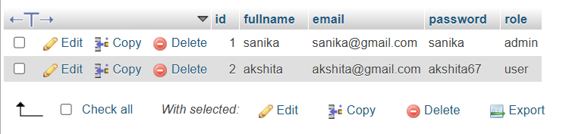
Step 2: Make Yourself Admin
Open phpMyAdmin → users table → Edit your account

Step 3: Create Admin Folder
Project structure:
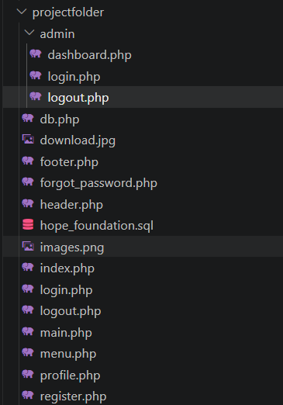
Step 4: Admin Login Page
admin/login.php
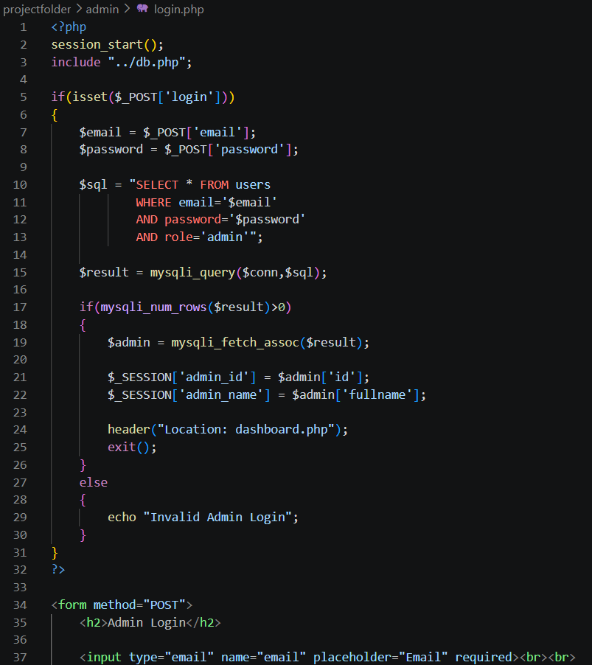
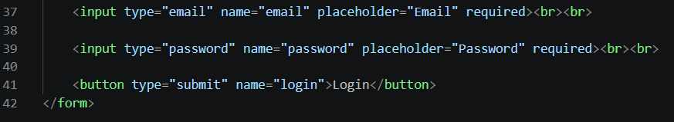
Step 5: Admin Dashboard
admin/dashboard.php

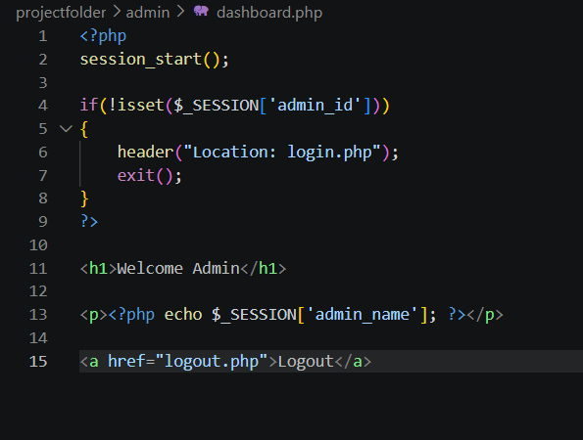
Step 6: Admin Logout
admin/logout.php
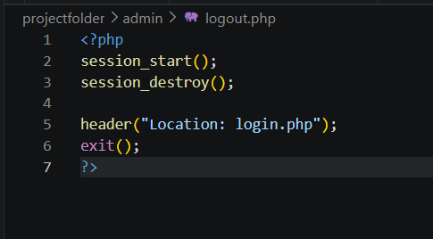
Step 7: Test
- Register a normal user → role = user
- Change one account to admin in phpMyAdmin
- Open:
http://localhost/projectfolder/admin/login.php
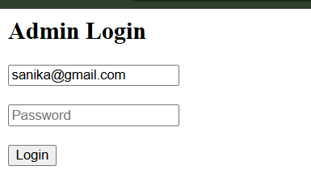
- Login with admin account
- It should open Admin Dashboard
